PICOZED FMC QUAD -Ethernet

1)PZ_7030 Carrier board;

2)OP 031-1V8 Quad Eth board

Steps and Links Required :

1) Download https://github.com/fpgadeveloper/ethernet-fmc-zynq-gem

2) Build tcl script for respective boarrd as mentioned in README document .

3) run Build-petalinux script , it will create a project and image files with project specs.

4)create bin file for fpga using bit file in impl_1 folder (see petalinux guide)

$ petalinux-package --boot --fpga <FPGA bitstream> --fsbl <FSBL_ELF> --format DOWNLOAD.BIT

$ petalinux-package --prebuilt --fpga <FPGA bitstream>

load the boot and image in SD

5)Install cp210x Drivers (USB UART bridge) for windows

6)Install Putty terminal application.

7)Set static Ips for the PC – 192.168.1.10 and GATEWAY ....1.0

8)change in network manager setting - 1)enable telnet and tftp in programs and features 2) Firewall advanced settings ---> inbound and outbound settings---> enable IPV4 file transfer 3) allow networks search in windows firewall advanced settings / disable firewall.

9) conneect and boot the board – On Putty Serial COM we can see the boot and enter user and password- root

10) Now We can use topology 1 (only for individual port and pc) and topology 2(with pc-pc

Note : using iperf3 for topology 2

install yocto on system – petalinux- config -c kernel ( we can see yocto settings)

goto petalinux folder --> petalinux- config -c rootfs

goto user packages --> enable iperf3 ___

run -petalinux---build ( this will rebuild files with iperf3)

Port conf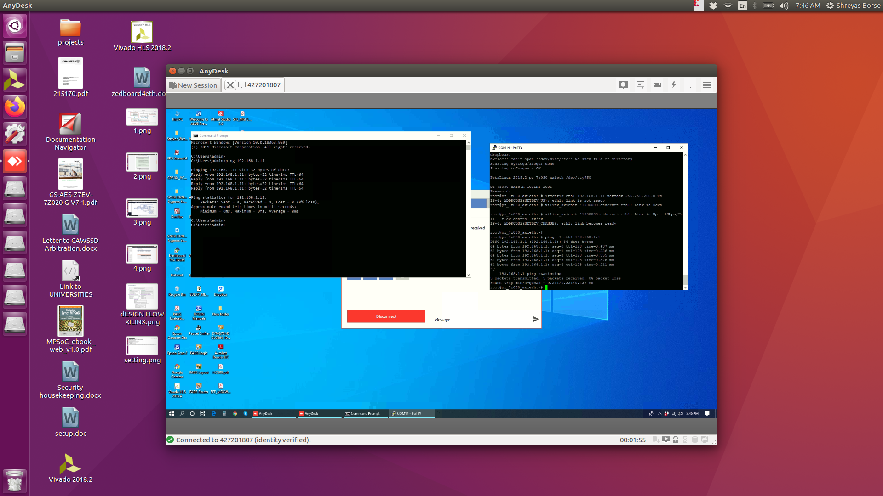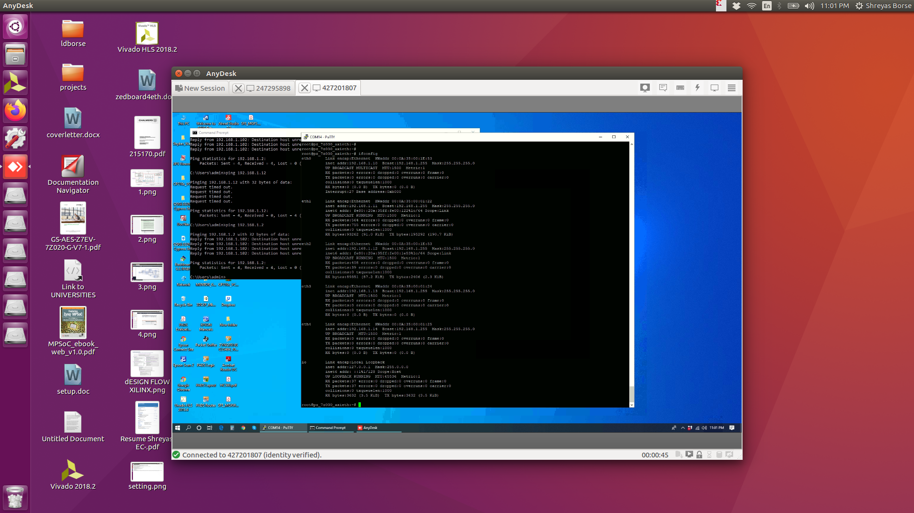igs PC1:

DATE- 6/8/20

1)Settings for both PC to enable ping:

a) Enable telnet and tftp in programs and features

b) Disable Firewall

c)Enable Publi Connection – windows firewall -printer and other devices – file transfer

d)Change IN bound Settings – advanced firewall options

e)Use Static ip and Gateway.

Topology 1

ETH1

ETH2

ETH3

ETH4

PC1

PC2

192.168.1.11

255.255.255.0

192.168.2.21

255.255.255.0

192.168.1.10

192.168.2.10

GW-192.168.1.0

GW- 192.168.2.0

Results and conclusion :

1)Since on one single ....1.1 network PC to PC ping was not working, Board was able to ping both pc and PC1 was able to ping board only.

2) using two differnt networks ....1.1 and ....2.1 with different gateways enable ping from board to pc and pc to board simultaneously but Still PC1 – PC2 ping was showing host unreachable

3)The next topology used with bridging for ip forwading on one network.

ping test for topology 1- PC1:

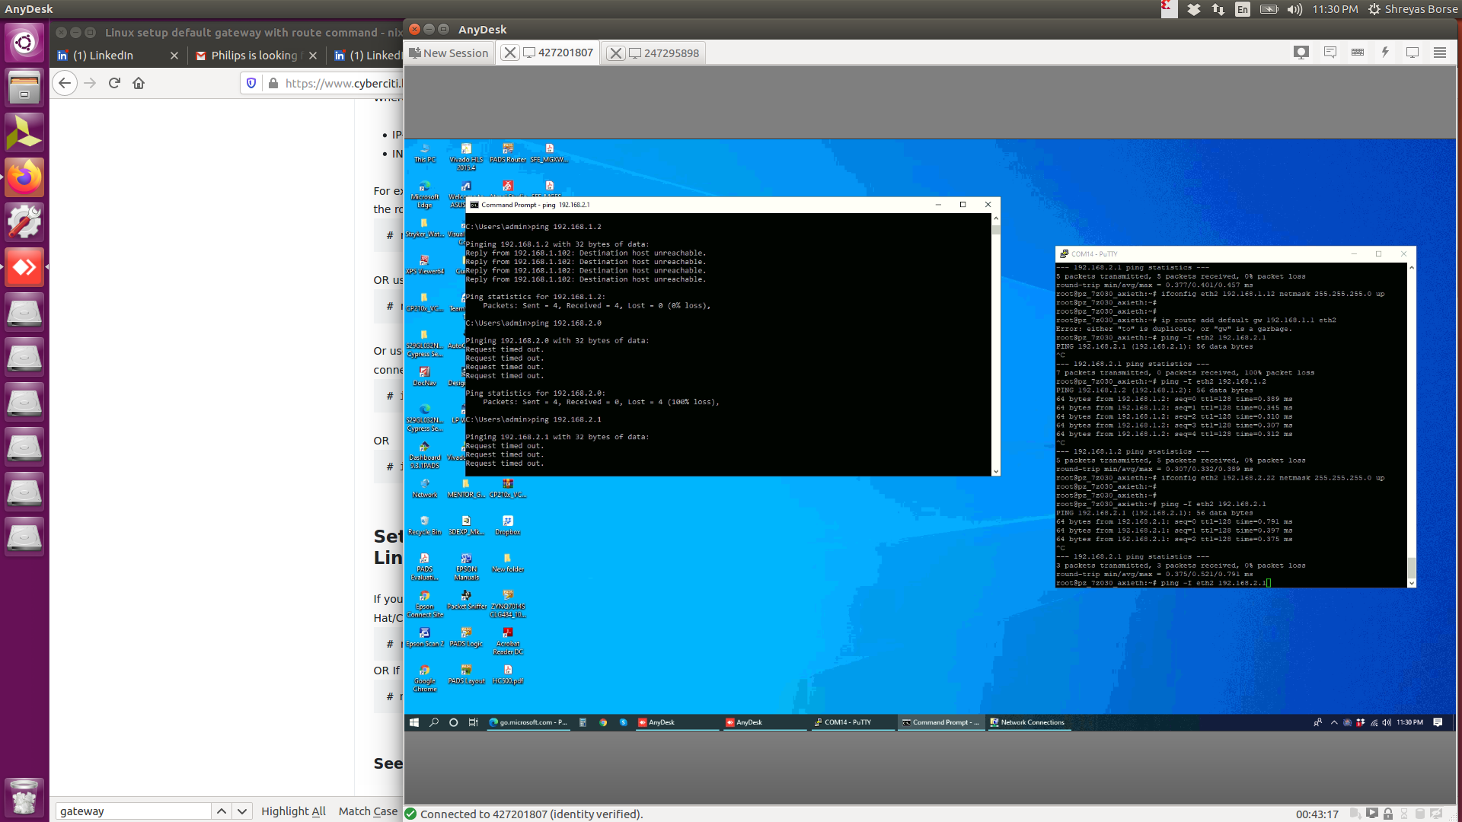

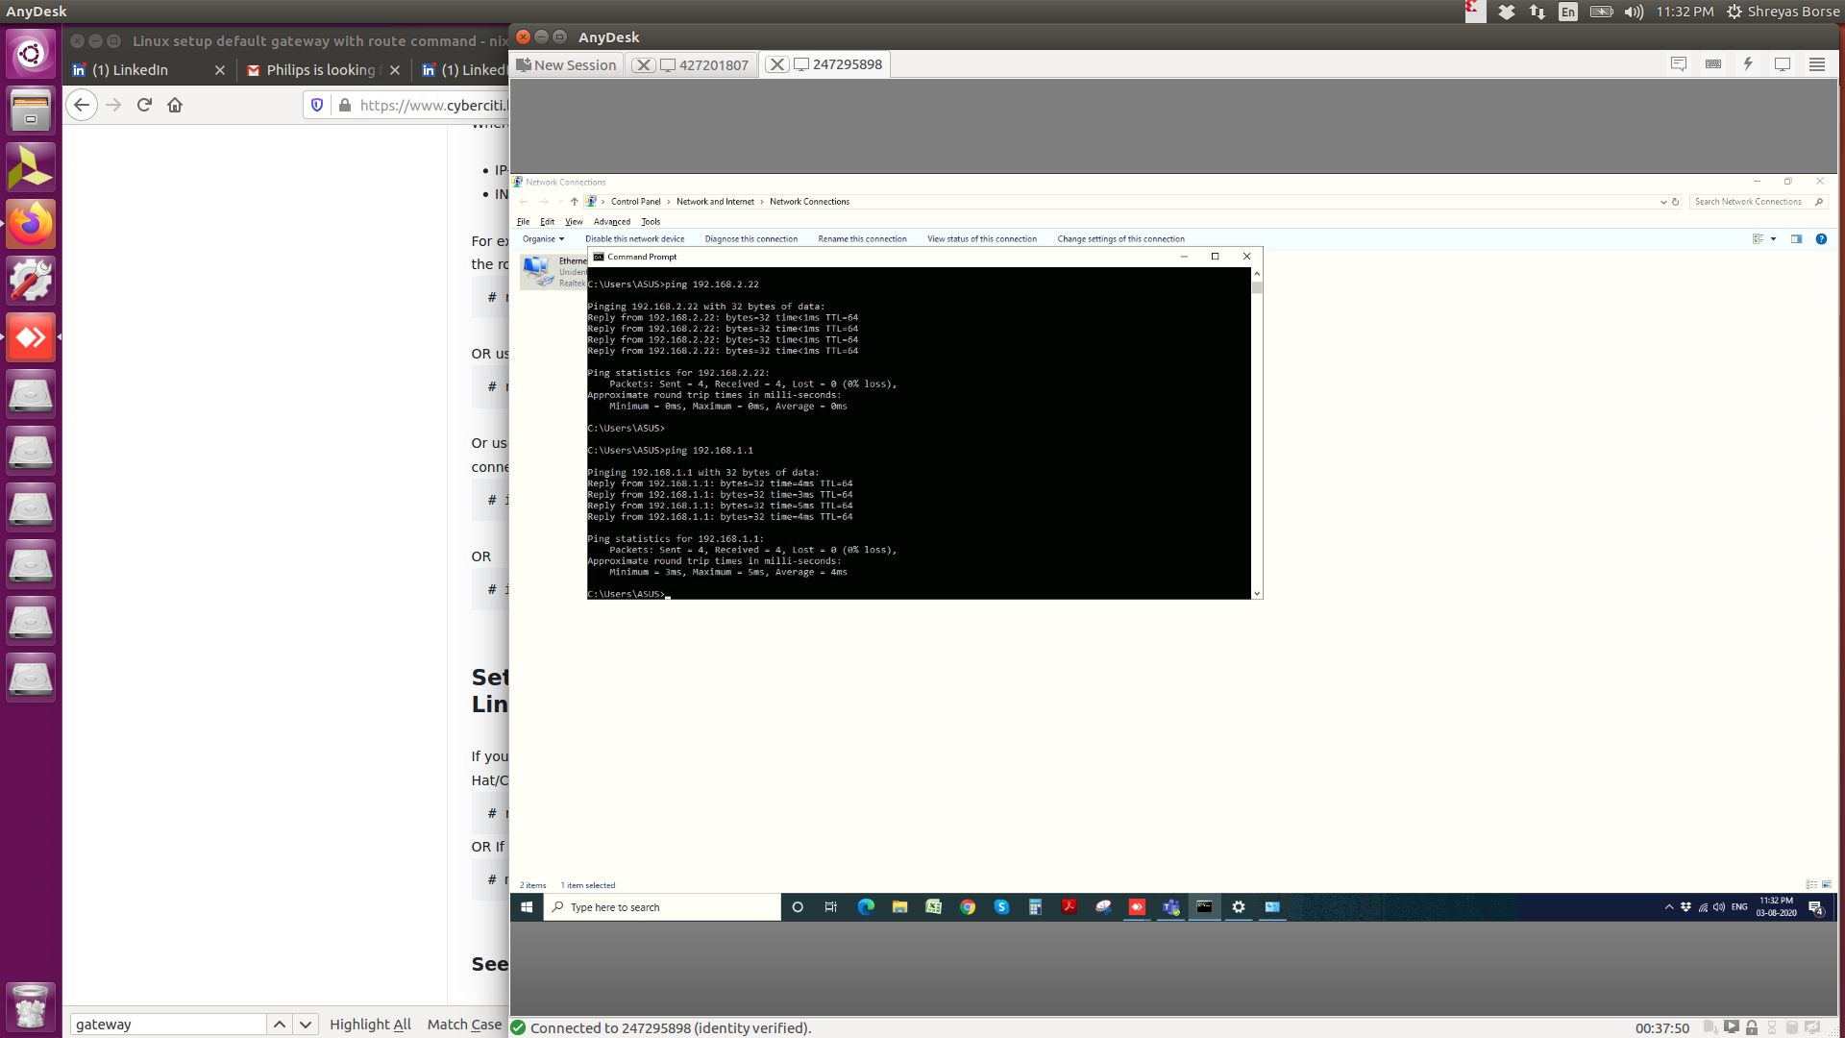PC2 CMD:

Topology 2

ETH1

ETH2

ETH3

ETH4

PC1

PC2

192.168.1.21

255.255.255.0

192.168.1.10

192.168.1.20

GW-192.168.1.0

GW- 192.168.1.0

192.168.1.11

255.255.255.0

192.168.1.100

This is board new-IP now

Using IP forwarding / port forwarzding we can enable connectionn between multiple ports on a same network -https://www.linux.com/news/what-can-you-do-second-ethernet-port/

CONFIGURATION:

There are three methods mention Bonding Bridging N Firewall commands(for LAN connection) :

1) ifconfig eth1...........-- for all ports

2)Bridge commands after configuration of ports are :

ifdown eth1 and sudo ifdown eth2 and...........

3)brctl addbr bridge1

4)brctl addif bridge0 eth1

5) brctl addif bridge0 eth2, brctl addif bridge0 eth3, brctl addif bridge0 eth4

6)ifconfig bridge1 192.168.1.100 netmask 255.255.255.0

7)ping -I eth1 .IP_PC...... from board and also ping from PC to PC

Results:

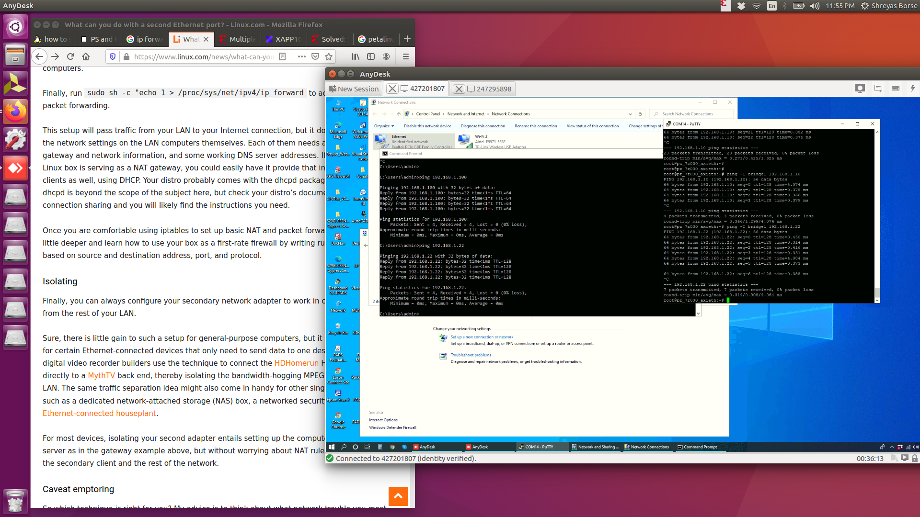PC-PC PING

PC2 - O/P

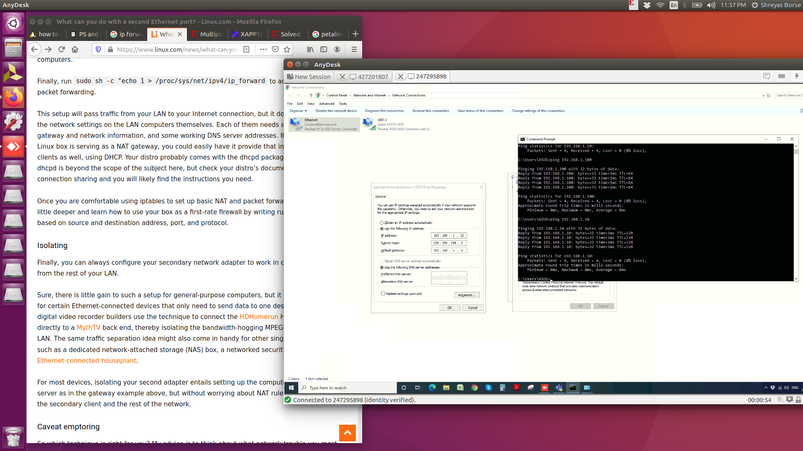

we can use iperf3 to check continues transfer on both ends

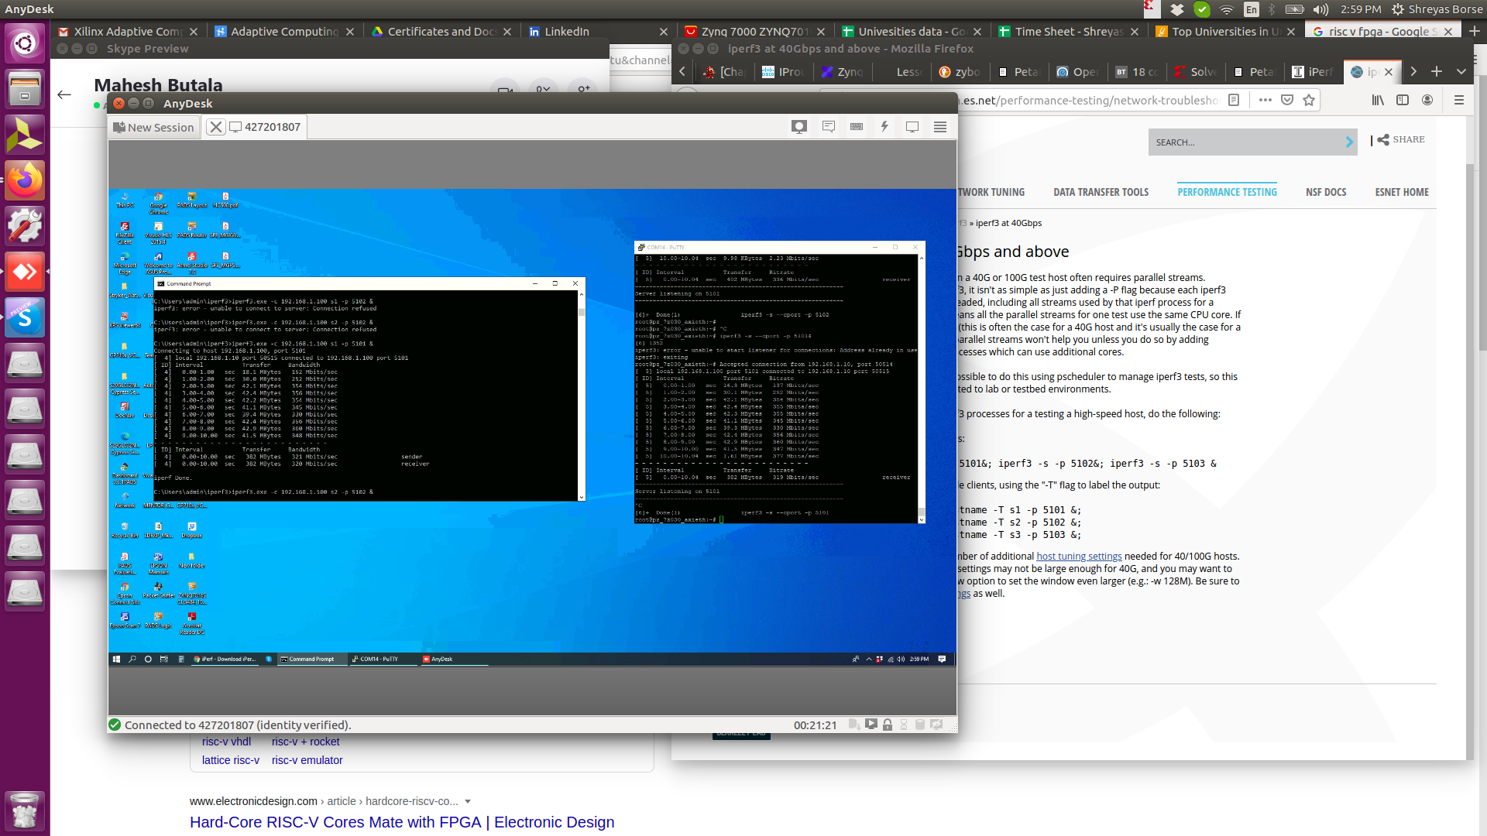

We can use 2 putty terminal if we want multiple server

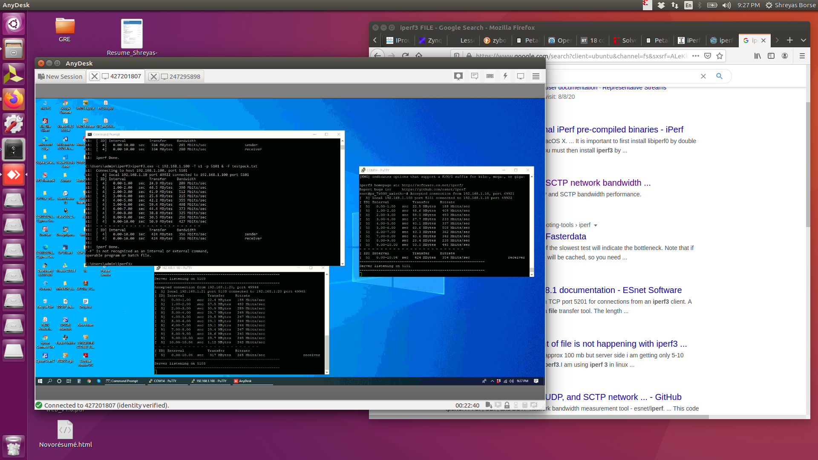

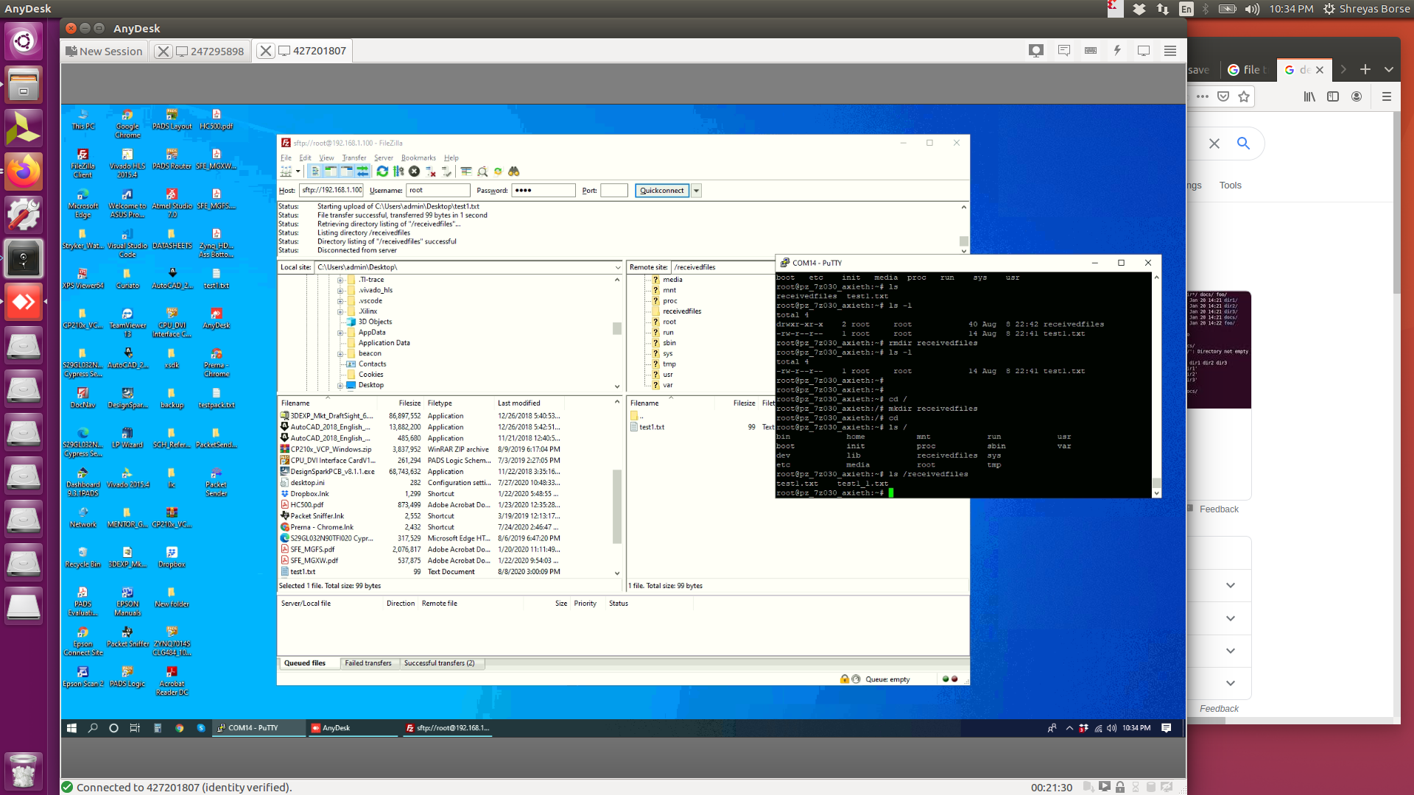Here I installed fileZilla to check file transfer from 1 end to zynq , and it stores in /home/root

